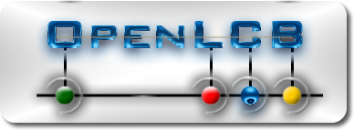
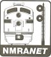

OpenLCB/NMRAnet
Developer and Early Adopter Kit
QUICK START

Thank you for trialing and/or developing for the OpenLCB/NMRAnet project. Your contribution is vital for the successful adoption, and continued development, of this control bus.
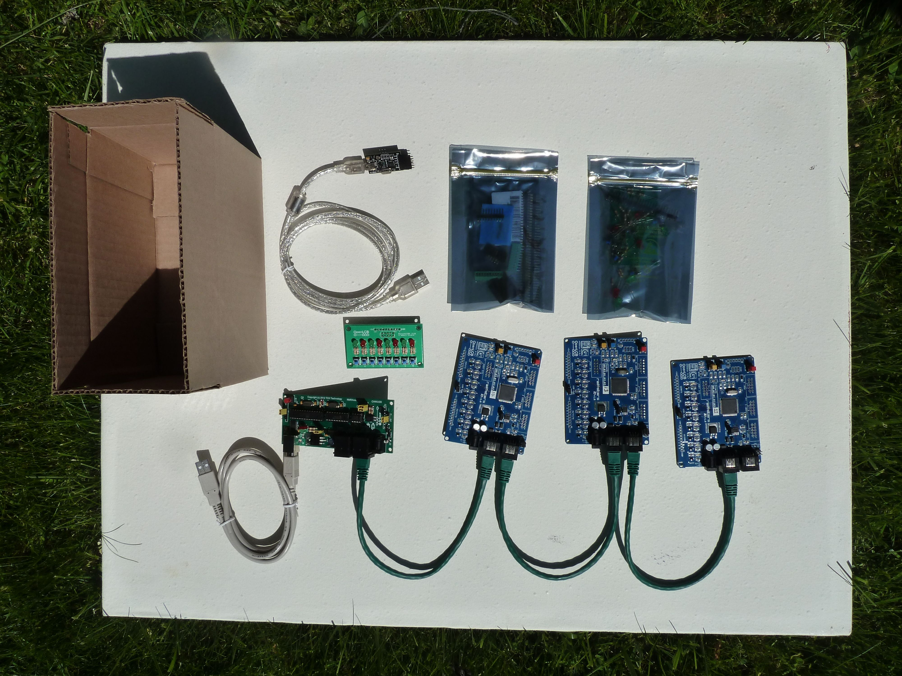
Contents of the Kit
- Three Railstars Io, OpenLCB/NMRAnet compatible, boards with three CAT5e cables
- One TCH Technology CAN/USB adapter board with USB cable
- One assembled ButtonLED8 I/O board
- One USB Serial Light Adapter with USB cable
- One ButtonLED8 kit of parts
- A selection of I/O connectors, and jumper wire
- This Quick Start Guide

NOTE: You must supply a power supply: 8-12V DC 2.1 mm Centre Positive.

Quick Start
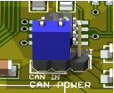Power IN
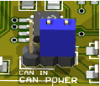Power OUT
- Select two Ios – you need two nodes to form a network and let the nodes initialize properly.
- The first will supply power to the other, so put the CAN-Power option-jumper on the first board to OUT, and the jumper on the other board to IN.
- Connect the two boards together with a CAT5e cable.
- Supply power to the 'OUT' board: both board's Green-power LED should light and each board's Blue-Led should flash three times. Then, both the Gold and Blue LEDS should flash on together briefly. Finally, the Gold-LED on each node should flash every two seconds, to indicate that it is active and has initialized properly.
If any of the above does not happen, then please double-check your power supply and the option settings.
- Take the supplied jumper wire and insert one end into the GND hole of the INPUTS. Touch the other end of the wire to one of the INPUTS (but not the 5V), and one LED on each node should light, corresponding to the INPUT selected. Explanation: touching the INPUT sends an event-number over the network. Both boards have matching event-numbers for INPUTS and OUTPUTS, therefore triggering an INPUT causes the matching OUTPUTS on each node to light.
Using the TCH Technology CAN/USB Adapter with JMRI

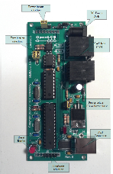
Connect the adapter to one of the Ios with a CAT5e cable. Connect the adapter to your computer with its USB cable. Run JMRI, and its preferences panel. Push the Save button, and OK to the restart question. Set the power option selector appropriately. Select the appropriate baud rate, 230400 for a Mac and 500,000 otherwise. See the manual for details.

JMRI should restart, and an OpenLCB tab should have appeared. Click on it and open the Console window, as shown to the right.

Push the Reset-button on one of the connected Ios, and a series of messages should appear in the console window as the node boots up.

JMRI has other features that let you configure your nodes. Explore. For example, in the OpenLCB tab, select 'Configure Nodes' and an OpenLCB Network Tree window should open. Double-click on OpenLCB Network entry in that window. A number of nodes should appear. Double-clicking on one of them should open up a configuration window.

Using the ButtonLED8 board

Insert a male 1x10 strip of male headers into the row of 10 holes on the ButtonLED8 board. Soldering in a female header makes this easier. Then insert into one of the Io boards in the Input position, and apply a little pressure so that the connection is solid. Pushing any of the buttons should light the corresponding LEDs on BOTH Ios.

For More Information

- OpenLCB, See http://www.openlcb.org
- NMRAnet, See http://www.nmranet.org
- Railstars Io Boards: See http://railstars.com/wp-content/blogs.dir/13/files/2012/04/Io-Users-Manual.pdf
- ButtonLED8: See http://www.openlcb.org/trunk/prototypes/hardware/ButtonLED8
- TCH Technology CAN/USB, See http://www.tchtechnology.com/products/can_usb/CAN_USB.pdf
- JMRI, OpenLCB support: http://jmri.sourceforge.net/help/en/html/hardware/openlcb/index.shtml

This DevKit could not have proceeded with much help for many people, so thank you to the following contributors:
- Railstars / Don Goodman-Wilson for node schematic and PCB design, software/firmware and documentation;
- TCH Technology / Tim Hatch for USB-CAN adapter;
- Silicon Railway / David Harris for node schematic and PCB design, mini-board design, procurement;
- John Plocher , Peter Jensen, David Harris, and the NMRA, through Stephen Priest, for seed money;
- Finally, Alex Shepherd, Bob Jacobson, John Day and others for ideas and support.

